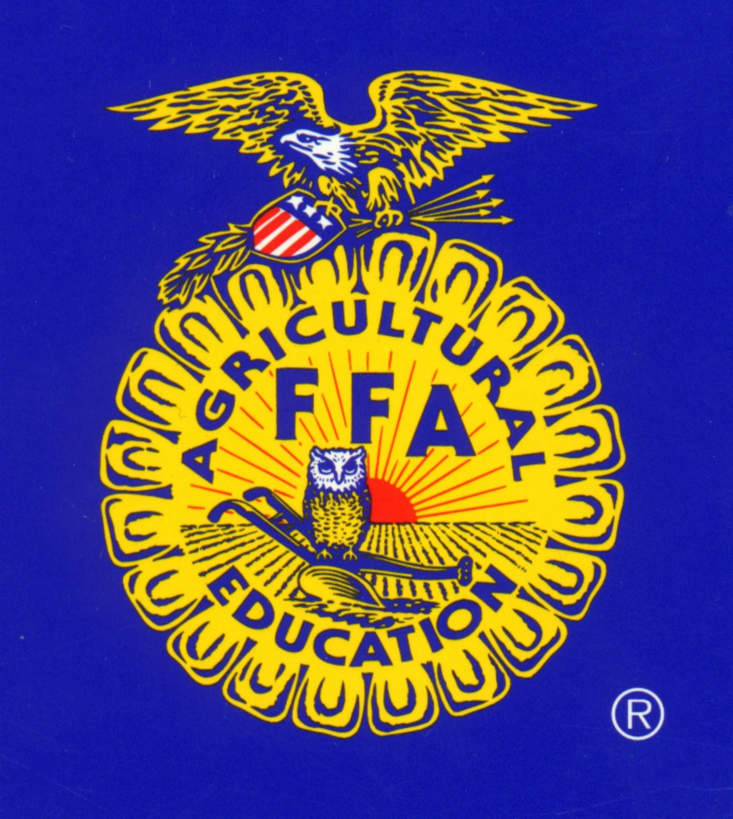
KATY FFA BOOSTER CLUB
Annual Dinner/Silent Auction

Dear Friends of the Katy FFA:

This year’s Silent Auction is scheduled for December 4, 2018 and we ask for your participation in making this our most productive Auction ever! We can’t do it without YOU! Your donation of auction items will go a long way in supporting the Katy FFA program. Anything of value will benefit our organization! If you like or find something interesting/unique, donate it or get it donated to the auction…most people will find these items of value as well. It is simple…the more items we have the more money we raise.
In past years, the money we raised has been used to purchase technology equipment, livestock trailers, jackets, calculators, travel expenses to contests, as well as the purchasing of animals at the FFA Livestock sale. Your continued support is vital to us being able to provide these types of items to the FFA students and the tradition of the FFA experience at Katy High School.
Your donation will be prominently displayed with your name or business name at the auction. The value of the item is tax deductible. A form is being provided below for your tax purposes.
The Katy FFA Booster Club and the FFA student participants truly appreciate your support and welcome the opportunity to prove that the Katy FFA program is an investment in our community and heritage.
If you have any questions or you would like to donate, please do not hesitate to call.

Sincerely,

Jan Douglass
Katy FFA Auction Committee
281-797-2204
jandouglass@consolidated.net

- - - - - - - - - - - - - - - - - - - - - - - - - - - - - - - - - - - - - - - - - - - - - - - - - - - - - - - - - - - - - - - - - - - - - - -
2017 TAX RECEIPT
Tax ID# 43-2032344

Thank you for your donation(s) to the Katy FFA Booster Club!

DONOR NAME: __________________________________________________________________

COMPANY NAME: _______________________________________________________________

ITEM(S) DONATED: ______________________________________________________________

_______________________________________________________________

*** SUPPORTING YOUTH IN AGRICULTURAL EDUCATION **

